- Generate test cases using Langchain has been updated with following features
  - Added config page for all key management
  - Supports auto fallback model when the rate limits reaches
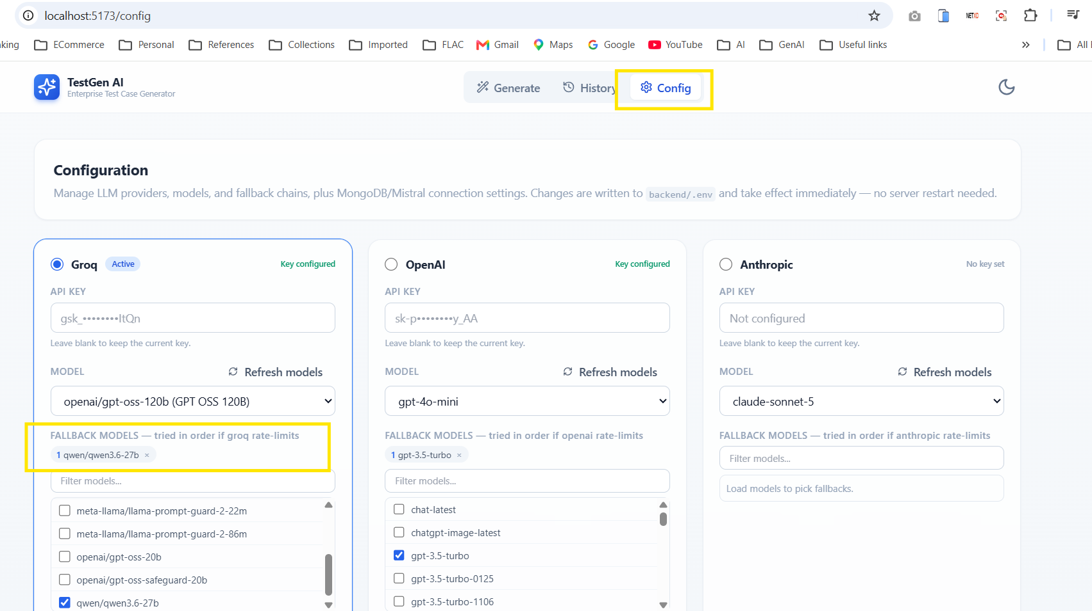

  - Auto detects domain when file is uploaded and allows user to override when unable to identify domain
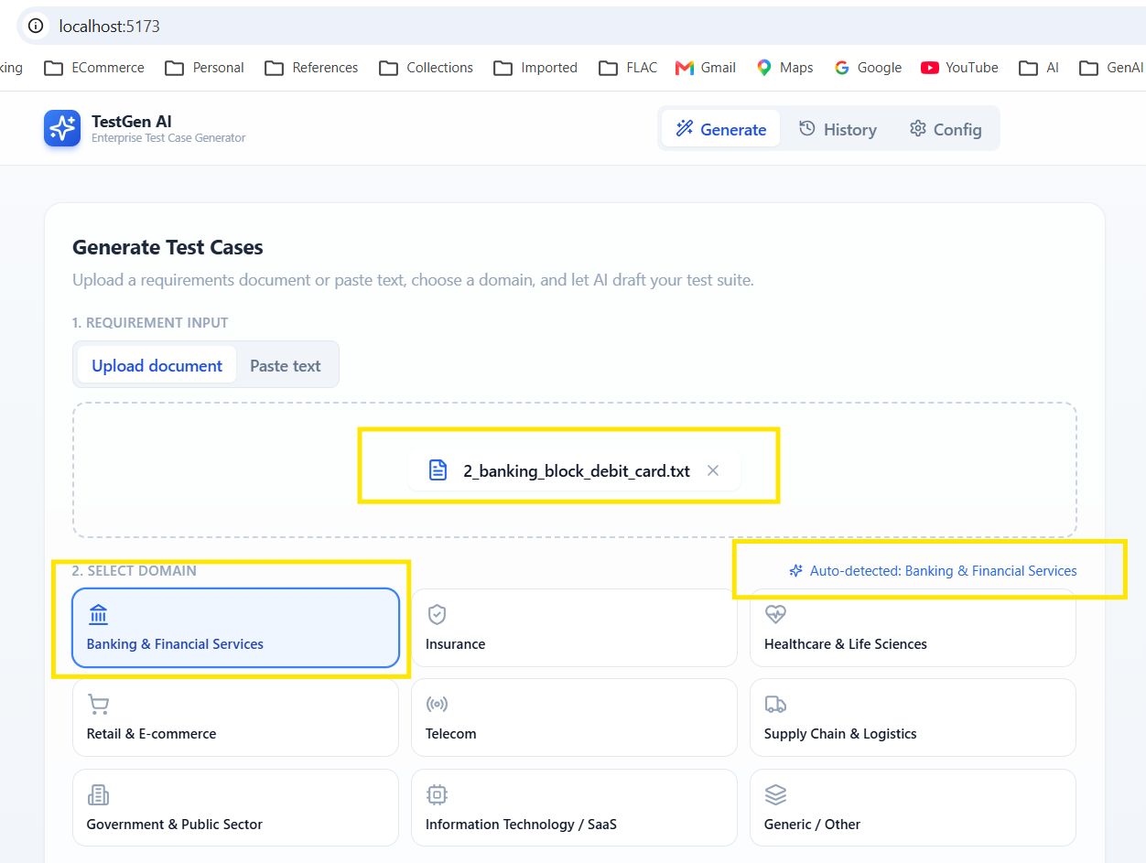
  - Once user click ‘Generate Test Cases’, it shows the list of API calls made and time taken for easy reference.
  - It shows the model that is being used and input & output tokens consumed
  - Generated test cases will be displayed in tabular format and can be exported to xlsx, csv, pdf and docx formats.
  - Maintains history of already generated test cases and user can download again anytime.
